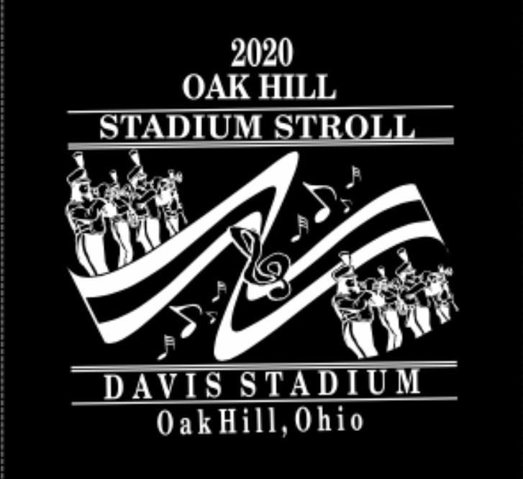
TSHIRT ORDER FORM – DUE FRIDAY 9-25-20

STUDENTS NAME:________________________________
CHECKS PAYABLE TO: OAK HILL MUSIC BOOSTERS
SMALL-XLARGE - $15 SMALL______ MEDIUM_____ LARGE _____
2XLARGE -$16 XLARGE ______ 2XLARGE______3XLARGE____
3XLARGE -$17 TOTAL>______________________

